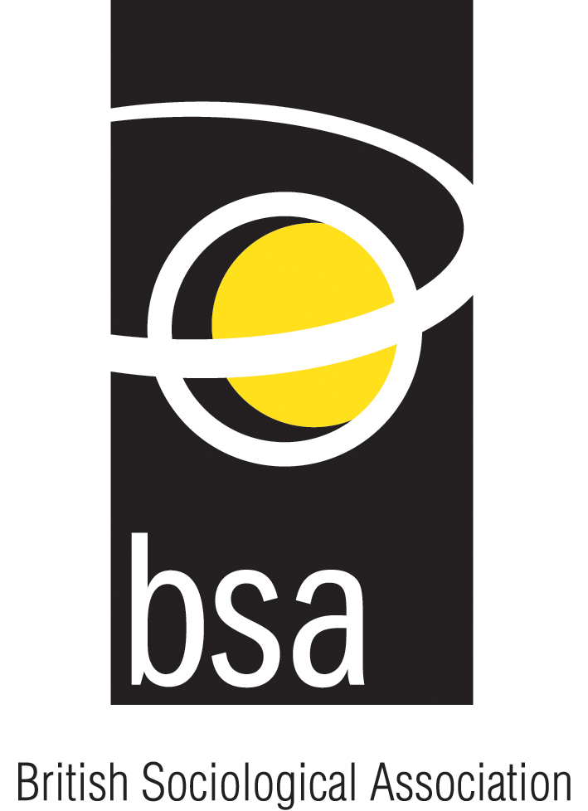
BSA FOOD STUDY GROUP (SCOFF)

FOOD POVERTY
“Acting local, thinking national”
SEMINAR AND WORKSHOP

Monday, 11th September 2006
University of Westminster, London
10:45-1:00
*Followed by lunch at local restaurant*

Claire Milne and Lisa Wilson, from Sustain’s Food Poverty Project (FPP), will lead and chair this event. The FPP is exploring approaches and partnerships being developed to tackle food poverty so that success stories can be shared and solutions spread.

The aim of this meeting is to explore how best to engage academia and the voluntary sector (NGOs and grassroots community food projects) to bring about long-term solutions through policy change.

Claire and Lisa will introduce the FPP, its aims, objectives and activities (including the Breaking the Armlock and Peanuts for Benefits campaigns) before facilitating an in-depth discussion about food poverty research, examples of good local practice and how the academic and voluntary sector can best effect policy change.

Who should attend?
Academics, researchers, community food/education workers and anyone with an interest in tackling food poverty.

This meeting is free to attend.
Please contact Libby Bishop to reserve a place.
(E ebishop@essex.ac.uk, T 01206 872664).
Further details also available from Wendy Wills
(E w.j.wills@herts.ac.uk, T 01707 286165)
www.food-study-group.org.uk
www.sustainweb.org/foodpoverty

